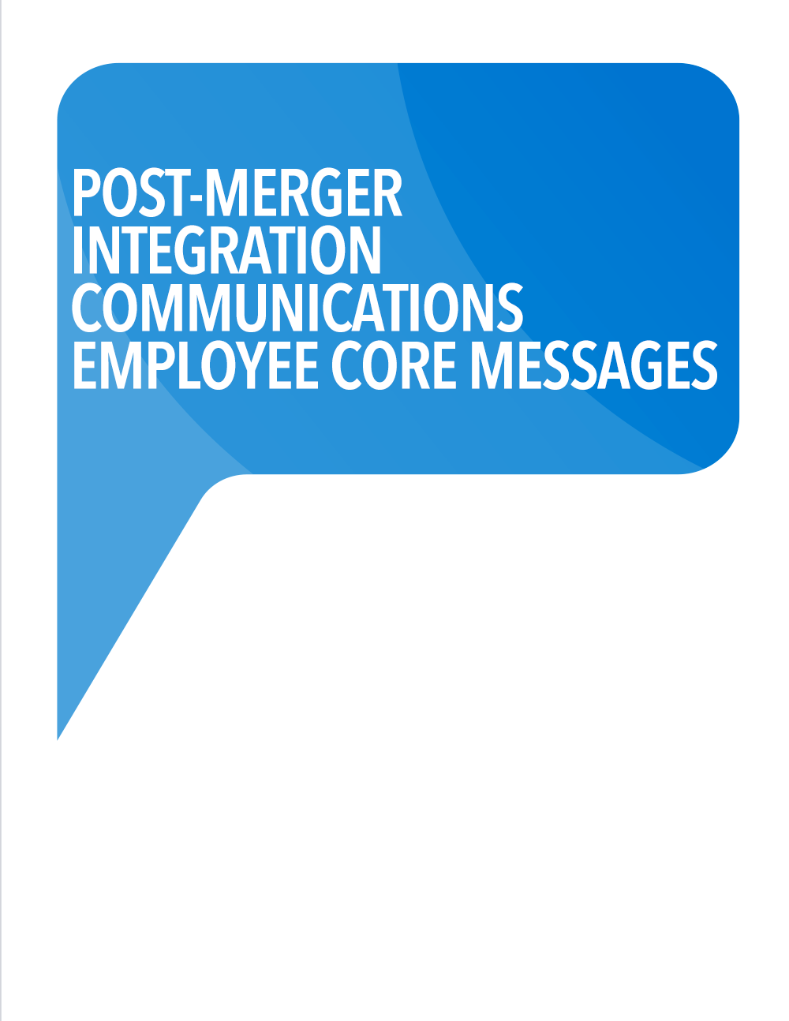
POST-MERGER INTEGRATION
CORE MESSAGES



Employee Core Messages
Acquirer is pleased to welcome Acquiree to our growing organization.

Investment to Fuel Continued Growth
To help us stay on the leading edge of our industry, Acquirer is committed to continued growth and ongoing investment in the software market.
- While Acquirer’s marketing & sales efforts have created awareness and demand for project management solutions, they are primarily targeting the top end of the market.
- Acquirer intends to take a leadership position in the mid-market where the largest number of companies exist.
- Customers in emerging and mid-market enterprises require a unified & data-driven collaboration platform to unlock productivity gains within their organization and to deliver complex projects more efficiently, predictably, and profitably.
- The target market for Acquirer’s project management solutions is approximately 10,000 companies in the United States. This represents a $50m recurring revenue opportunity for Acquirer.

Strategic Rationale
Acquirer and Acquiree have strikingly similar origin stories, compatible organizational cultures, a complementary core focus, and naturally distinct segments of the market. The acquisition of Acquiree will amplify our market identity and draw more attention to our solution for clients.
- Acquirer focuses on the Mid-to-Enterprise markets (‘up-market’) with user-defined configuration options, robust system-wide extensibility, and embedded financial workflows and controls.
- Acquiree focuses on Small to Mid-Market clients (‘down market’) with functionality such as cost estimating, scheduling, contracting, change management and billing.

Our intention is to:
- Improve Acquirer’s competitive position within our target market
- Increase enterprise value as the acquisition is accretive from the outset
- Block a strong competitor from acquiring Acquiree and competing with Acquirer
- Continue rebuilding our GTM engine into which Acquiree ﬁts neatly
- Assimilate Acquiree’s strong talent and management team into Acquirer’s organization

Expected Outcomes
The Acquiree acquisition is consistent with Acquirer’s strategy and objectives. Integrating our two companies is intended to create long-term value by:
- Increasing market share in our target market segment
- Strengthening competitive position
- Having stronger ﬁnancials and balance sheet
- Increasing Acquirer’s enterprise value
- Focusing our development / roadmap strategy
- Strengthening our Leadership team

Keys to Success
- 100% retention of existing Acquiree clients post-acquisition
- Minimize attrition from Acquiree personnel as a result of the acquisition
- Ability to clearly articulate market / segment positioning of the entire portfolio
- Hiring a sales and marketing team capable of executing the vision
- Operating capital to effectively market launch a new, stronger Acquirer

Shared Vision, Mission & Values - Guiding Principles of the Integration
- Ensure that people, culture & communications are at the center of the integration plan
- Strive to have this acquisition benefit our customers and the construction community at large
- Mitigate disruptions to the normal course of our business
- Actively participate in the efforts to successfully integrate our businesses
- Raise the quality of our work in all aspects using new and better ideas and practices
- Work collaboratively to establish an operating structure for the larger Acquirer
- Operate with strategic urgency with a clearly defined decision-making process

Communications Channels
Your first point of contact for questions about the integration should be your manager. We will also have a general resource to route and answer additional questions via [insert email]. We will use a number of communication channels to inform and engage our employees about our vision, strategy, and performance. These include:
- Leadership Letters (via email)
- Recorded Webcastings – updates distributed over the Internet using streaming media
- Web postings - Integration Update(s) to be provided frequency/monthly
- FAQs – intended to be kept current through date
You can expect to see several meetings and events land in your calendar in the coming days and weeks – if they aren’t there already. Some of the key ones include:
- Live Webcastings – updates distributed over the Internet using streaming media
- Town Hall – in-person local Q&A gatherings
- Social Events – informal local gatherings

